20+ pages & 50 + quotes, sayings, & phrases to ponder & get the juices flowing. wriiten by andrea-rachel

(i put quotes around
my own words because
i like the aesthetic.
just like i like lower case letters.
miss me with the bs.)

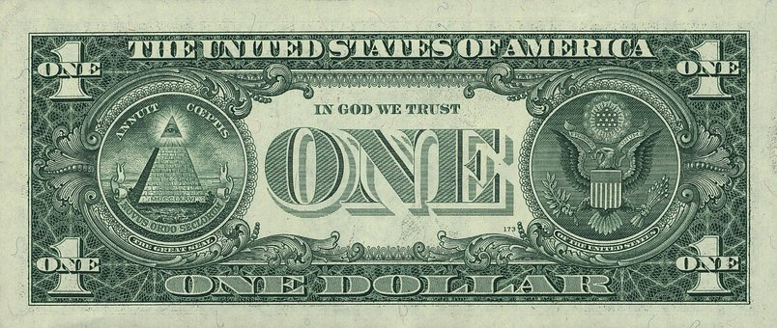

growing a backbone only comes with the ability to first love yourself & then secondly, trusting yourself.

may we live a life that creates ripples of our best selves, works & experiences throughout the lives of the people we love.

“when it comes to love, its always ends up being about that little bit of ‘je ne sais quoi’. that thing that you just can’t quite put your finger on.”

there is pretty privilege & then there is that.. everyone wants to be around that. we dont know why, and we really don’t want to.. people operate off of feelings more than they’d like to admit & the proof is usually tied to the person who most people try to keep others away from… find the hidden ones. the ones where its hard to get all of them… they have it. and they’ll make you feel like you’re the best person to them… but that’s there thing, unless they don’t like you… they make everyone feel special.

-------

- commitment is the precursor to planning but planning isn’t a resource without commitment.
- kindness looks aggressive to people who only recognize it without boundaries.
- the safes places to travel are the places you experience with the people who make you feel safe.

“..may the best of your today be the worst of your tomorrows.”

“..being better than yesterday doesn’t mean seeing differently than before.”

“..you can make anything by writing.”

“..everyone fails at something, but i cant accept not trying.“

“..it’s kind of fun to do the impossible.”

“..if you can dream it you can do it.“

“..incredible things can be done simply if we are committed to making them happen.”

“..don’t let a bad moment trick you into believing you have a bad life.” unknown

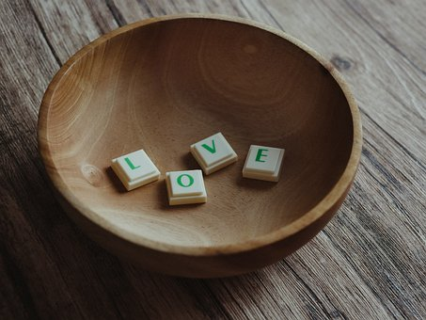

i created a company for people who have disabilities, differences, deformities & etc, and watched everyone go around mocking me as though I had a difference. the most interesting part was to see what that idea means to different people. ever saw a person act as though they have a stereotypical learning disability due to the fact that they are in the presence of a burn survivor. who do you think looks special in that scenario. so i quickly learned,

these are just some thoughts, phrases, quotes i’ve “thunk” up…while living / existing. some inspired by others testimonies, journeys, stories theories and quotes, but mainly what my brain does as it takes in its environment & processes.

i hope you guys have fun with these quotes.
tell them to your kids. reiterate them in motivational talks, barbershop conversations, salons, classrooms and etc. lolol jk jk

the reality is.. i don’t make much of them once i’ve understood them. but that doesn’t mean it wont inspire something from someone else. just use them responsibly.. i do not care if you're objective or subjective .. or disprove nor argue about any of these candid quotes. just credit if anything.
the images are just reflections of what i feel rightnow in these moments. nothing too far to read into. With so much going on, being able to take this moment out to generate this, just feels like a luxury I do not want to take for granted. was going to select images that spoke more directly to my demographic, but felt like adding pieces of me into it instead so the stock images are just that… stock, that resonate with me.
you can summize whatever you wish from these phrases they are for the person who is looking to just have something new to read. with the idea that maybe nothing is ever really new, and with the idea that maybe even, nothing is as real as we think… and going into … everything is only as real as we make it.. these expressions are just soft glimpses of the theories, and concepts that play. you can read and laugh, read to understand, dive deep or read and let go.
not sure who will read or what interest is out there in this day and age for this type of stuff because most people (even me) are way more into visual stimulation and concepts but there is a tiny portion of me, that wants to at least do the things i say while i can.
wanted to provide a monologue book & a reflections book down the line based off the bts of the projects I was on… but it seems like i cant for reasons I don’t fee like sharing today. but i can do this… I can do this and i can do it in such a way that it no longer matters who downloads it, reshares it privately among their friends… and makes it so that it is read by everyone…it will be there, in it’s own existence.

some have said with disdain, that i think too highly of myself.
and with this..
all i want to say is…
& i hope one day you think too highly of yourself too.
------
to those that often forget that their aura radiates celestial star dust which can reach the paradise.
writing words strong enough to remind you that your being blazes wars or stills conscious.
words specific enough to massage the mind or dagger the heart.

trying to match words
eloquent enough
to remind you
that they will always
need you more than you need them.

words that create a desire so strong you’re forced to honor yourself by asking questions, seeking answers & always creating paths best suitable for your framework.
you are art.

disclaimer:
any similarities, to any scripted or non scripted project, art, media, is strictly coincidental and no efforts were made to further use nor plagiarize any piece of material seen here-within, any redistributed quote has been properly credited.

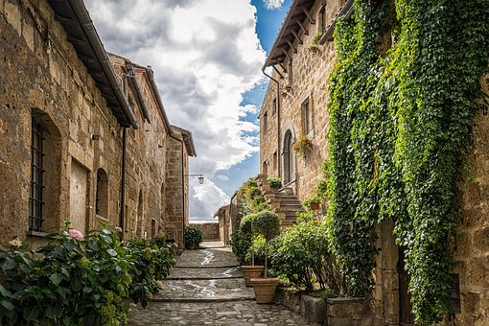

-----

“to find your standard, own your mind.”

“the rules that are for your safety will also allow freedom.”

“do it because there are days where you think you cant. do it because there are days where you feel you shouldn’t. do it so that on those days, you have this one that reminds you, you are fully capable in whatever it is you set your mind to. ”

“nobody is listening, but then again, why does anyone have to? learn to let your words vibrate.. the desire alone will attract the proper outcome. ”

“when you aren’t feeling heard, ask yourself why we feel the need to? is there a reasoning beyond ego? outside of sheer selfishness?”

“sometimes it isn’t about what you know, but how well you come to the realization, that maybe, in fact, we all still do not know anything.”

“if there are others who blatantly express your desires out loud to spite you, they have already undermined themselves and rewarded your importance.”

“even if you do not need the act of help, it does not mean to fear the word itself. you can be strong and you can be smart & still rely on something.”

“the people who need you to need them, are usually only about themselves.”

“if it requires you to change your belief solely to make them feel good about having the ability to change you, it isn’t about growth at all but control.”

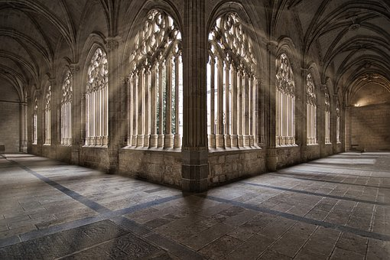

“if you lose yourself in anything, i hope it’s love.”

“imitation isn’t the only form of flattery.“

“the best place to live is a healthy mind. “

“may any brick thrown be used as a stepping stone for your path to greatness.“

“may we all have someone smarter than us, we feel okay to ask stupid silly questions to. “

“the more high energy you play in and around, the more high energy you receive.”

“stay in a place where you can be your highest essence.”

“to know your your highest essence, you merely have to feel.“

“careful listening to things you do not want to hear.“

“any word can sound good enough as prophecy if you decorate it enough.”

“the scared ones, will usually try to get you to change rather than to admit their fear.”

“the better parts of you should be shared, but let the smartest parts of you discern when to reserve them.”

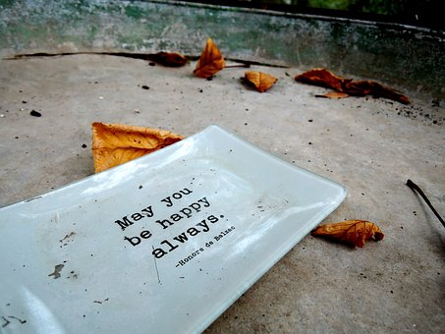

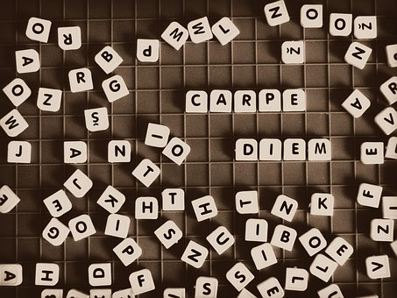

“the difference between ghetto & luxury is the prohibition to utilize our creativity to spruce up and add to our surroundings..”

“the only thing that can raise a child is love. fastest way to lose your child is to limit them.”

“a person in love becomes a fool, but a fool in love, becomes their most courageous. and the universe loves and responds to courage.”

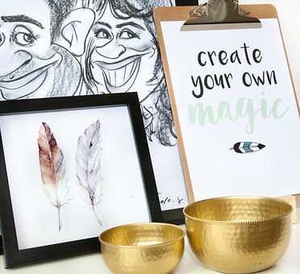

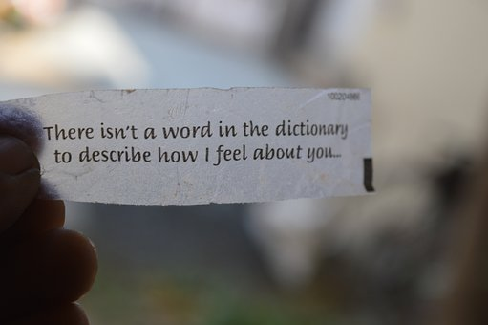

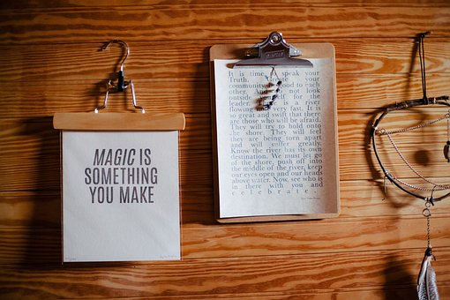

“the weakest mind, is the mind of someone who can see vulnerability in someone, and chooses to critique it before choosing to help it. ”

“the first place an opponent will try to attack, is the mind.”

“the similarities of creative genius can also be proof of collective conscious.”

“even with nothing to look forward to, there is still everything to be grateful for.”

“commitment has to first be made as an agreement within yourself.”

“the better player of any game will always be the one who takes their time.”

playing on words generated from thought equates to genius. used as punishment? merely desperation.

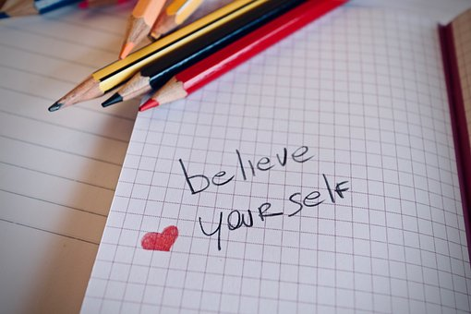
--------
a person vibrating higher than that of your current frequency which is hypothesized to be relatively low enough given the act of tastelessly pondering aloud how in fact i should dare think well for myself & instead should pontificate & objectify myself more in vain, due to my inability to decide a more leveled standard as you so see it.

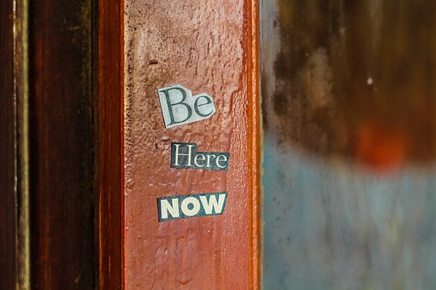

“the best food to feed the spirit is a belief in ones own self.”

“to let the idea of freedom move you, you first have to root yourself in trust & cloak it in understanding and grace.”

“the most energizing conversation with spirit is one basked in the feeling of freedom.”

“if they can control your words, they devalue you, if they can control your thoughts, they own you.”

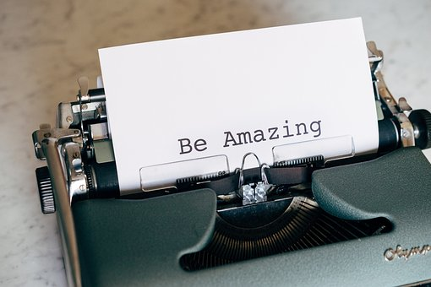

“give the grace you wish to receive“

“the best kept secret is the art of story-telling.”

“your only goal everyday, is to fall more in love with yourself, daily.”

“a strong mind helps heal.”

“be weary, if their only way of demonstrating their value, is to try & diminish yours.”

“ & anxiety is the feeling that the things best for you, are too good to be good for you.”

“if you’re with the right people, to lose yourself in love, is to lock yourself into bliss & peace.”

“to find courage, find something makes you fall in love.”

“the best way to lose fear, is to find happiness.”

“the best representation of who you are, will always be your most authentic self.”

“wherever you go, i hope you take yourself with you.”

“the privilege of a lifetime, is being who you are.”

“protection looks different for everyone. it exists as boundaries for some, and looks like freedom for some others.”

“truth is, people can

only meet you,

where their reality &

insecurities, intersect.”
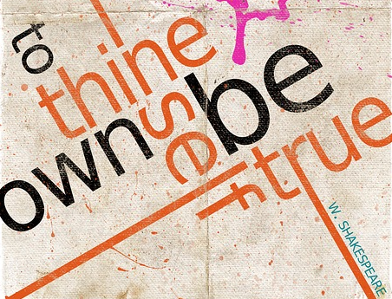

“suppression looks like silencing voices & trying to outshine the progress of others…it’s only done by the insecure.”
here is a tid bit people didn’t know. my voice sounds shaky when i haven’t slept, tired and i haven’t been taking my vitamins or supplements…because if its long winded, i literally get drained with every word.

*laugh break*

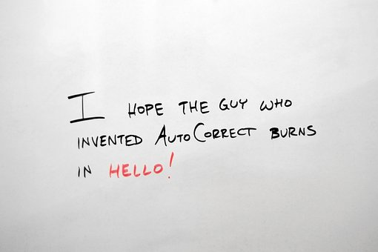

“materialize with the mind & mend with the heart.”

“integrity comes from those who have something to lose. integrity comes from those who believe their is more to gain. integrity comes from those who understands hard work.”

“you cant undermine flattery because it looks different to every person.”

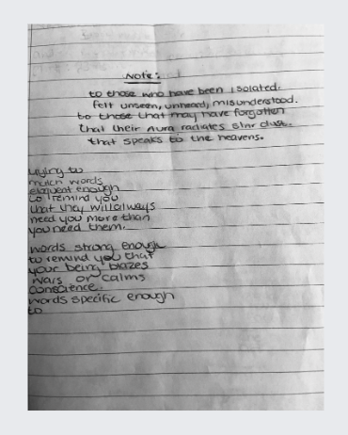

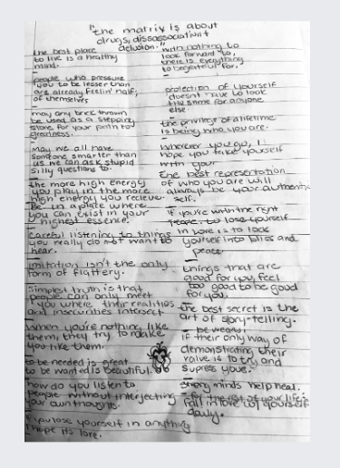

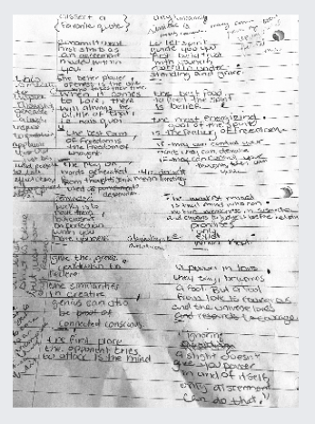

they may have tried to trick us out of our legacy; by making our peers, proteges, listeners & audience too busy to remember, to cold to care and to lonely not to be desperate. may we speak life, prosperity and legacy over ourselves & our loved ones. May we remember those who have inspired, may we remember those who have helped more than harmed, may we speak light of them from the past and greatness for the futures, and may the younger generations we encounter do the same. we we walk brazenly to the boldest parts of our creativity & may it be received with open arms for there is understanding of the turmoil it took to get to this level of peace.

may we always remember that the most valuable part of the mind, is to stay present

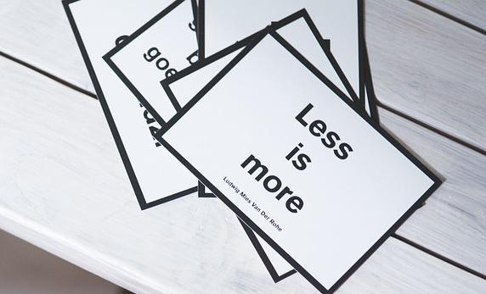

“..negus there’s plenty of us.”

